 

**Placement Empowerment Program**

***Cloud Computing and DevOps Centre***

Host a Static Website Locally: Set up a Local Server Apache and Host a Simple HTML page with your name

**Name: Shahana.M.S**

**Department : ADS**



**Introduction and Overview**

In this POC, we will learn how to host a static website locally using the Apache HTTP Server. This process involves setting up a local web server, configuring it correctly, and hosting a simple HTML page. By following these steps, you’ll get hands-on experience with configuring and running a local Apache server, which is a foundational skill for web hosting and server management.

**Objective**

The goal of this project is to:

1. Set up a local web server using Apache.

2. Configure the server to host static files.

3. Create and host a simple HTML page displaying your name.

**Importance of Local Hosting**

Local hosting is an essential skill for developers, as it allows them to test and experiment with web applications in a controlled environment. It offers several advantages, such as:

**Hands-On Learning:** Gain practical experience with server setup and configuration.

**Testing Ground:** Safely test and debug websites before deploying them to a live server.

**Offline Development:** Work on web projects without requiring an active internet connection.

**Step-by-Step Overview**

Step1:

Search for "Apache Lounge" on Google and click the first link to access the official website.

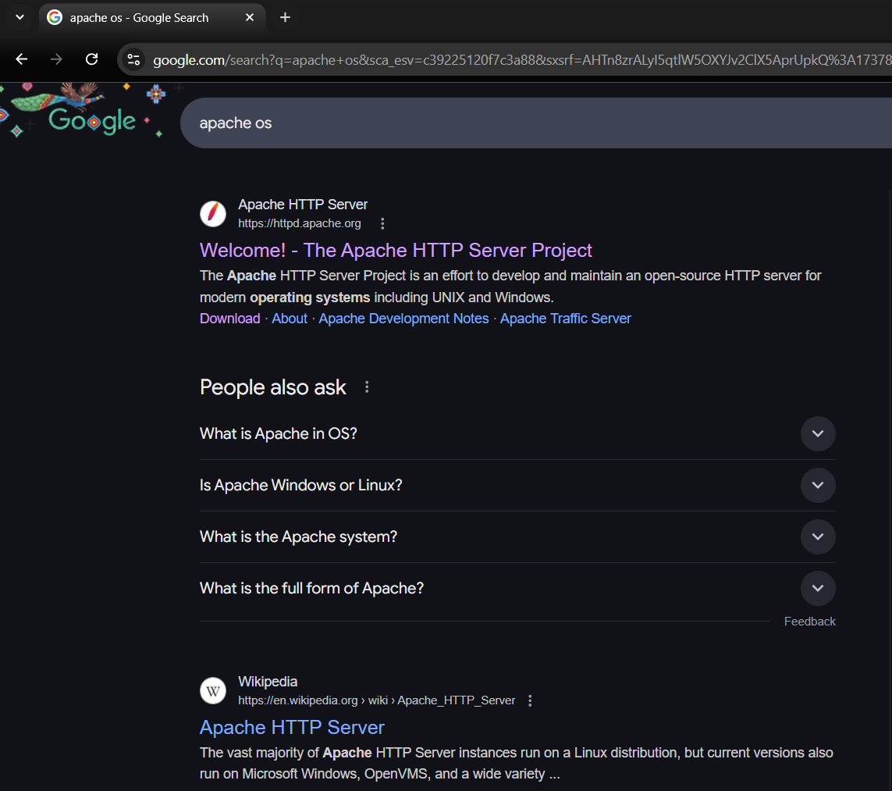

Step 2 :

Click on the "Downloads" option located on the left-hand side of the Apache Lounge website.

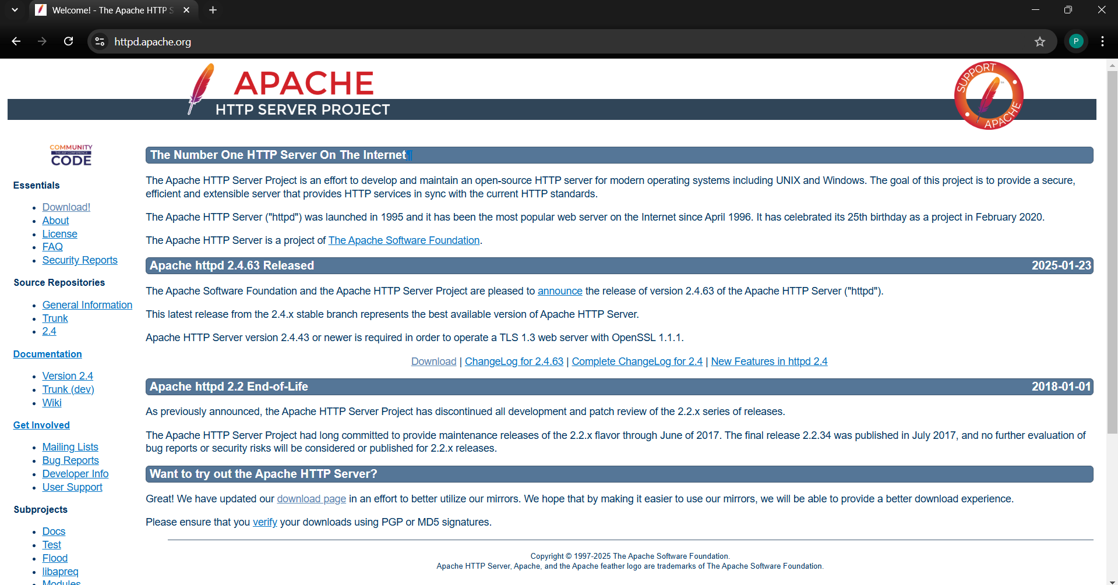

Step 3 :

Click on the link **"Apache 2.4.62-240904 Win64"** (Windows version), download the file, and extract all its contents.

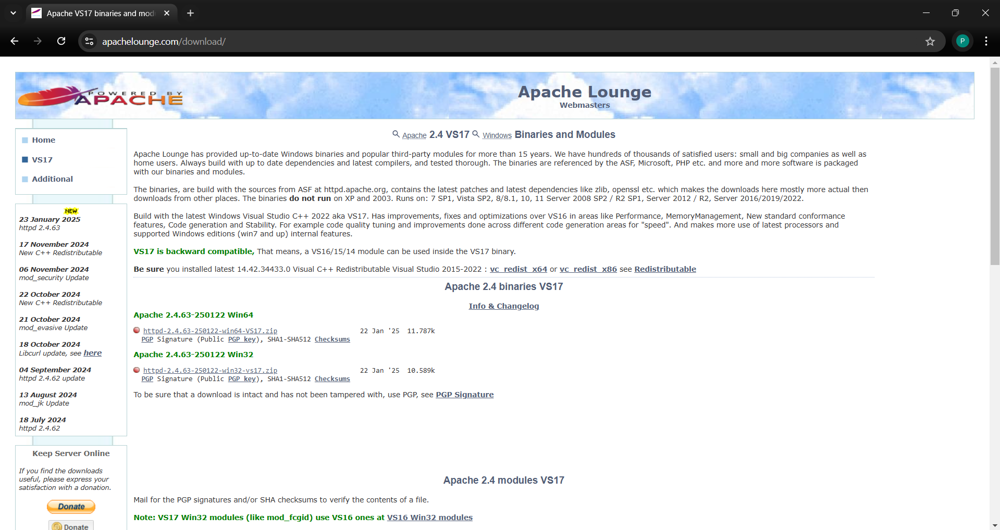

Step 4 :

Open command prompt , right click to run as admininstrator and enter the following commands in the the below photo

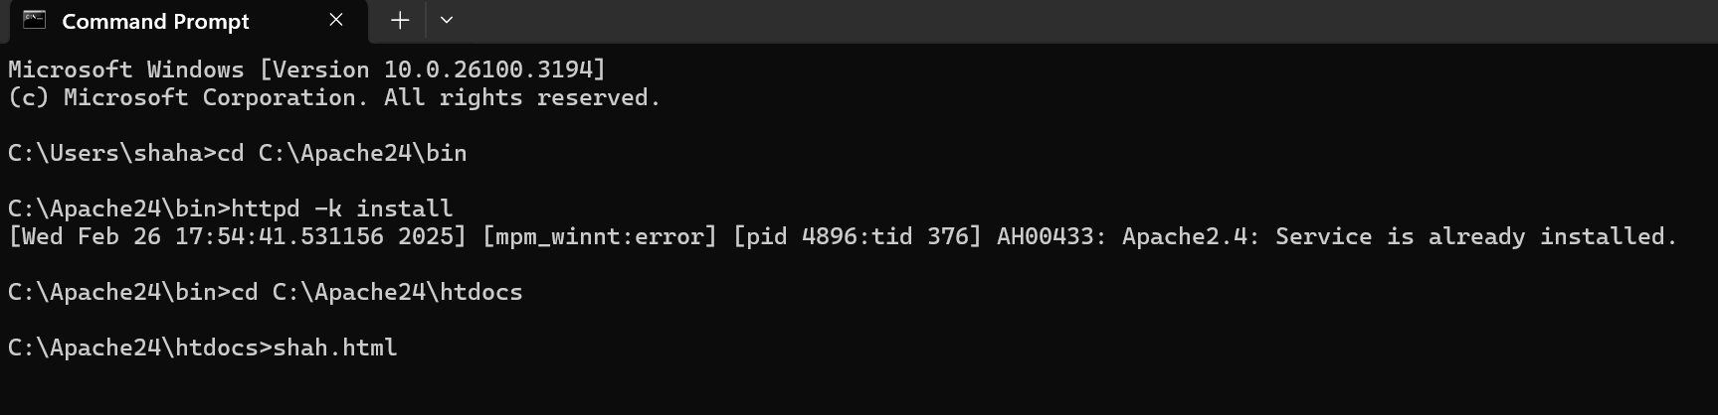

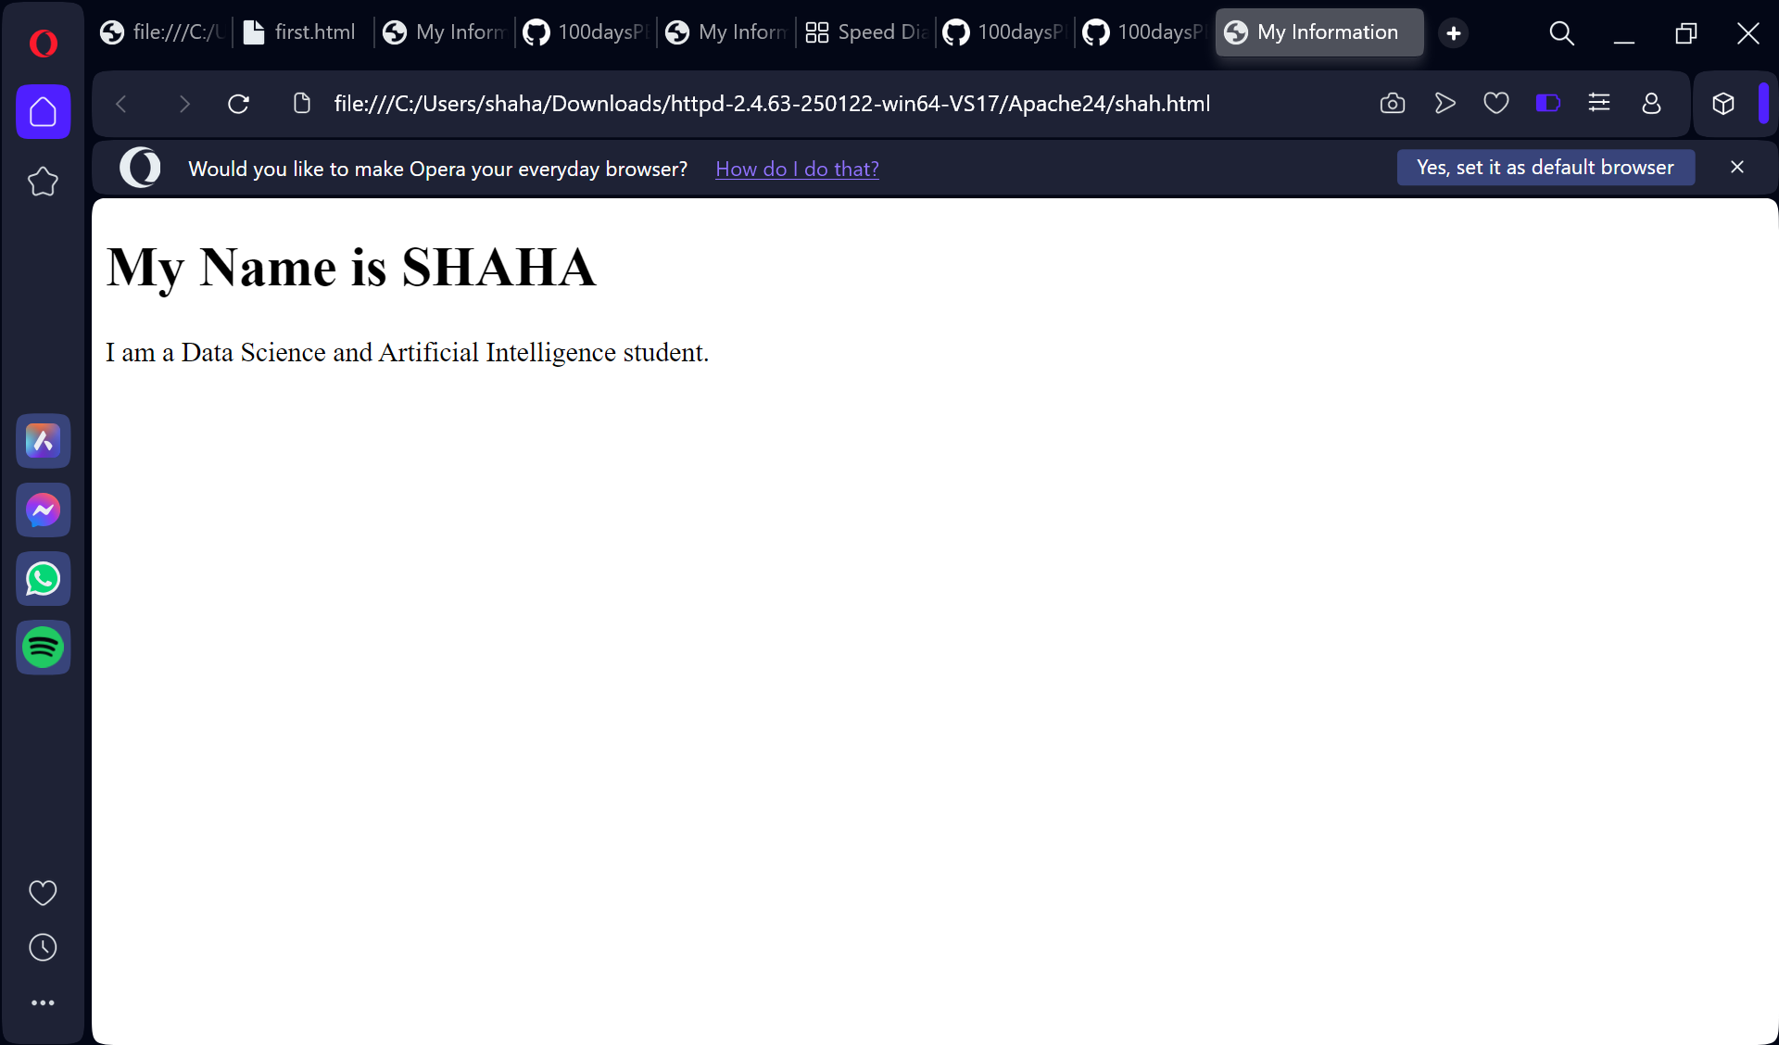

This is to be the following outcome that is received for this task, and this objectibve of this task .